Work flow screen shot:

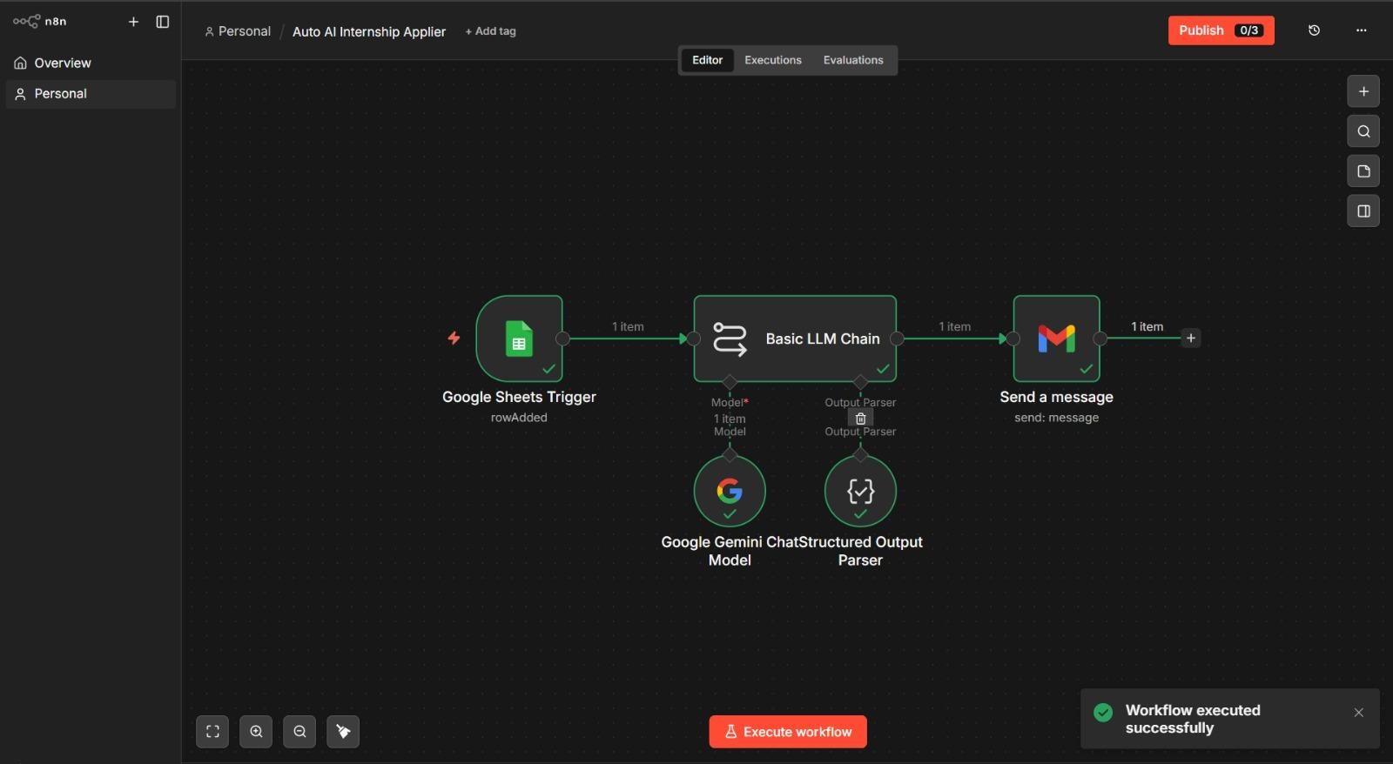

Output Screenshot:
